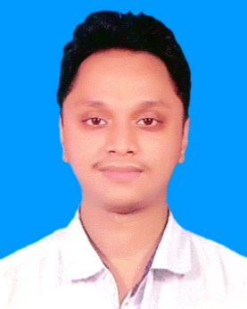**MD. TAREQ SHAH ALAM**

Mobile: +8801752669226

E-Mail: tareqshah.027@gmail.com

LinkedIn: [www.linkedin.com/in/tareq-aronnyo-bb6b771a2/](http://www.linkedin.com/in/tareq-aronnyo-bb6b771a2/)

GitHub:

# CAREER OBJECTIVE

Seeking a career to utilize my knowledge, personal skills to gain comprehensive understanding of a reputed organization to take responsibility and contribute significantly.

# EDUCATIONAL QUALIFICATION

|  |  |  |  |  |
| --- | --- | --- | --- | --- |
| **Category** | **Group/Department** | **Institution** | **Passing**  **Year** | **Result** |
| Bachelor of | Computer Science & | Bangladesh Army University of | 2022 | CGPA |
| Science | Engineering | Engineering & Technology, Qadirabad Cantonment, Natore |  | Appeared |
| Higher | Science | Notre Dame College, | 2017 | GPA |
| Secondary Certificate |  | Mymensingh |  | 4.72/5.00 |
| Secondary School Certificate | Science | Mukul Niketan High School, Mymensingh | 2015 | GPA |
|  |  |  |  | 4.00/5.00 |

# ADDITIONAL QUALIFCATION AND CERTIFICATES

* MSB Academy Certified Ethical Hacker. .
* Udemy Certified Ethical Hacker.
* Udemy Certified on Web Development With PHP.
* Udemy Certified on Web Development With Django.
* Udemy Certifid on Web API with ASP.NET

**SOFT SKILLS**

* Management to work effectively in team as well as individual.
* Have a strong commitment towards the quality work.
* Analytical Skill.
* Willingness to learn new technology.
* Leadership skill
* Interpersonal skill
* Content Writing Skill.

**TECHNICAL SKILLS**

Language Skills

* Python
* HTML
* CSS
* PHP
* Java Script
* C#

# PERSONAL DETAILS

**Date of Birth:** 05/10/2000

**Marital Status**: Single

**Gender**: Male

**Language Known**: English and Bengali

**Nationality**: Bangladeshi

**Address**: 8 Kalibari By Lane, Mymensingh Sadar-2200, Bangladesh

**References:**

1.Dr. Mirza A.F.M Rashidul Hasan

Professor & Adjunct Faculty,

Faculty Of Electrical and Computer Science,

Bangladesh Army University Of Engineering & Technology (BAUET).

Email: mirzahasanice@gmail.com

2. Dr. .Mohammad Golam Sarwar Bhuyan

Associate Professor & Head,

Bangladesh Army University Of Engineering and Technology (BAUET)

Email: csesarwar@gmail.com

3. Jim Al Sadik

Service Manager (Technical & Operation)

Exotico Solutions,

54/4-A, Basundhara R/A, Dhaka-1229

Email: jimalsadik@exotico.solutions